***NAME: ANMOL RAJ***

***ROLL NO: 001811001069***

**ML(Machine Learning) ASSIGNMENT 1**

**DATASETS USED :** IRIS Dataset, Diabetes Dataset, Breast Cancer Dataset

**Question 1:** Naïve Bayes Algorithm on all datasets

Before applying any training algorithm split data into training and test sets.

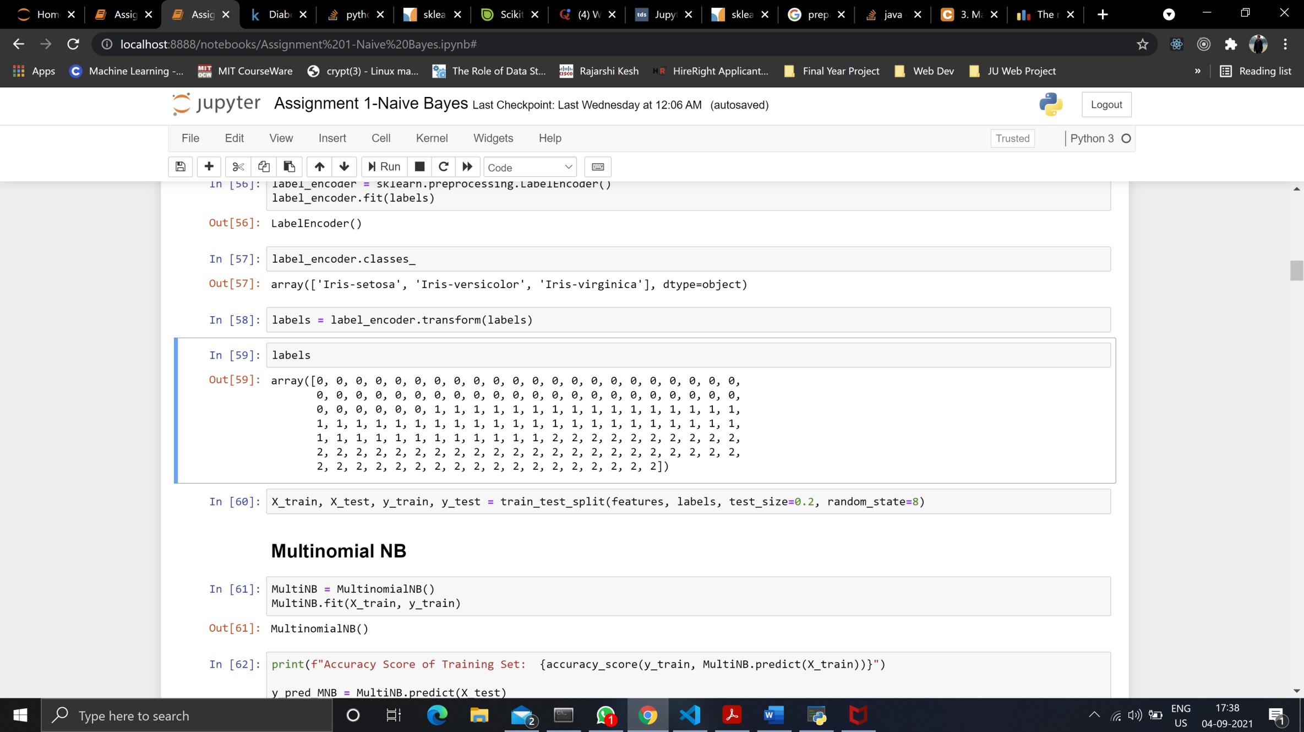

**IRIS DATASET**

***Prepare Dataset for training***

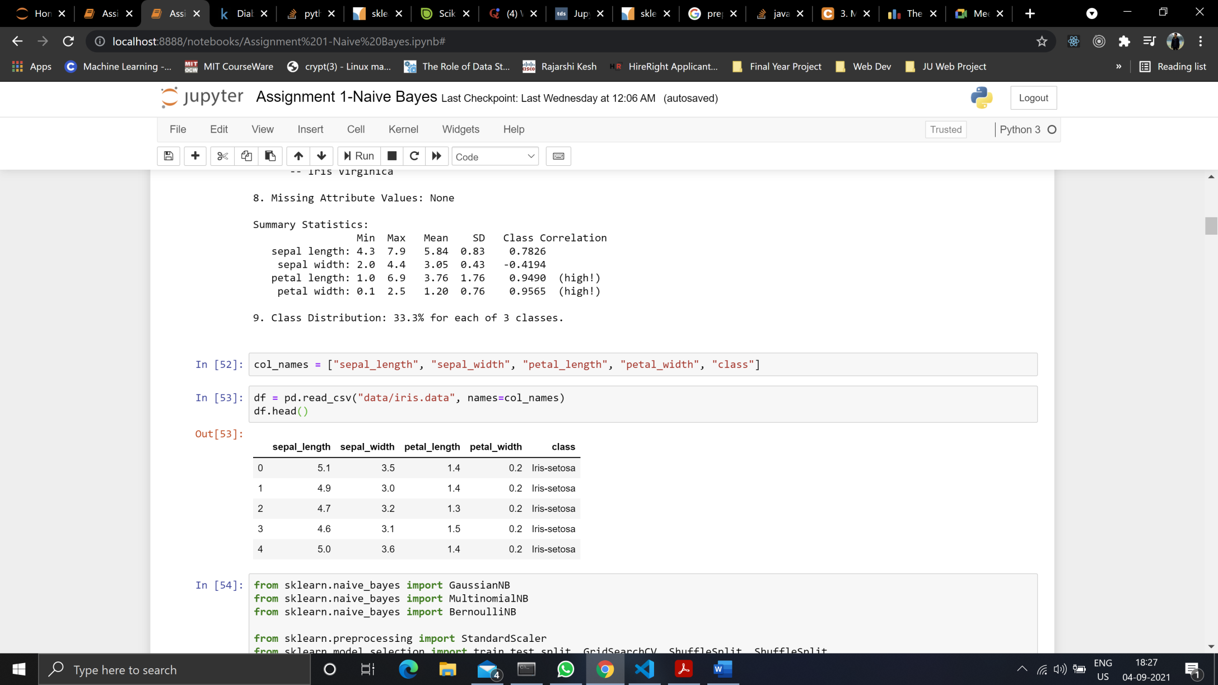

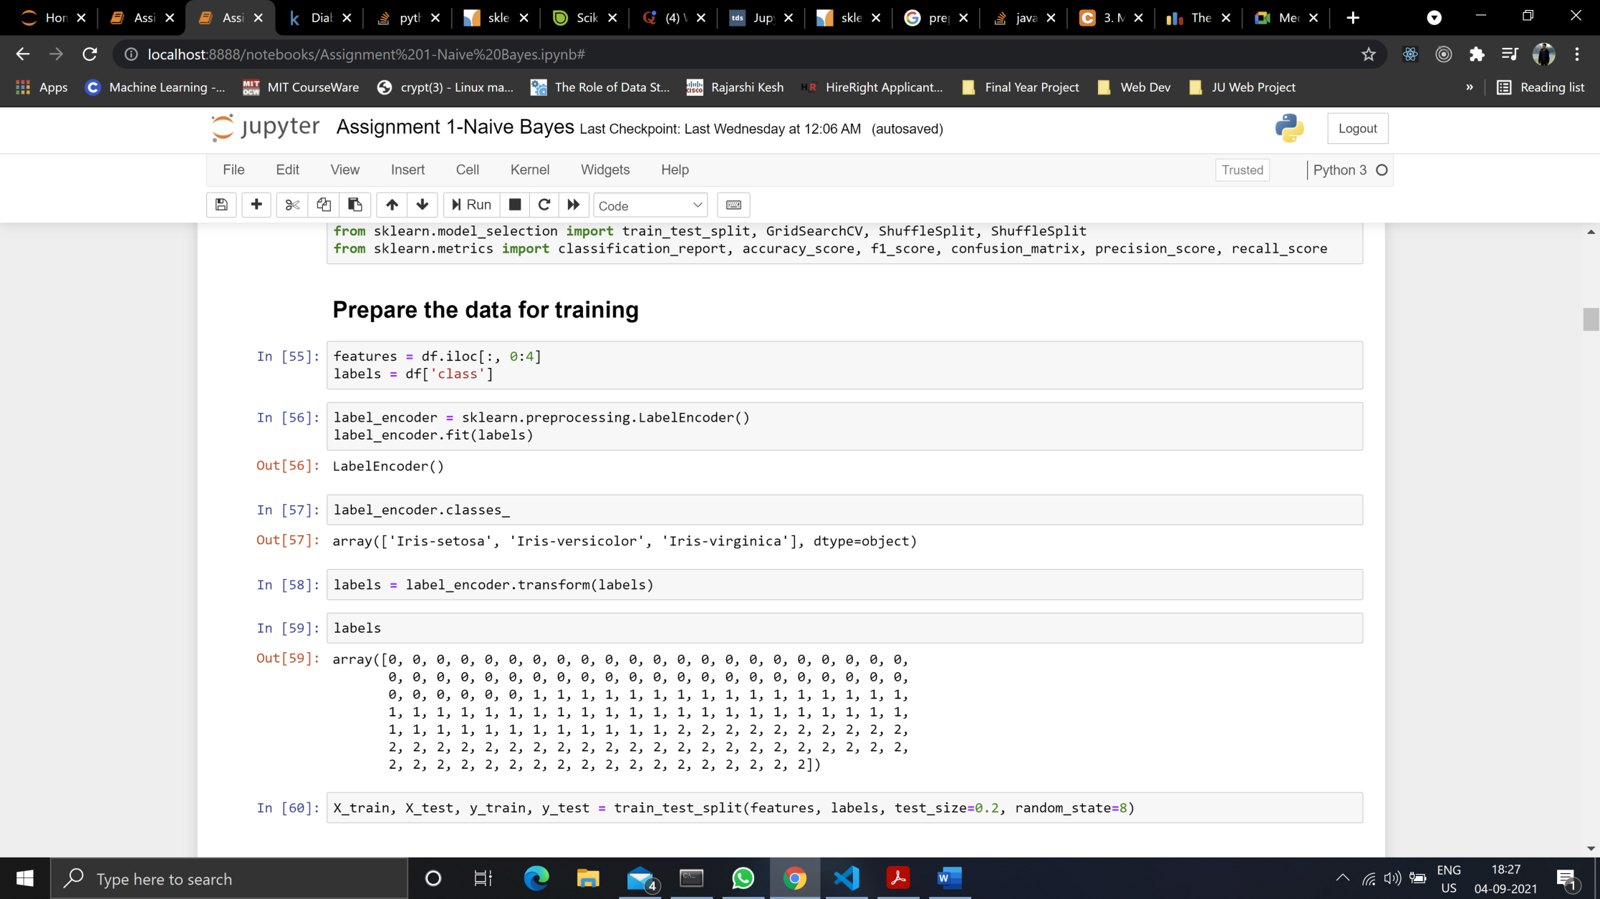

***Multinomial Naïve Bayes***

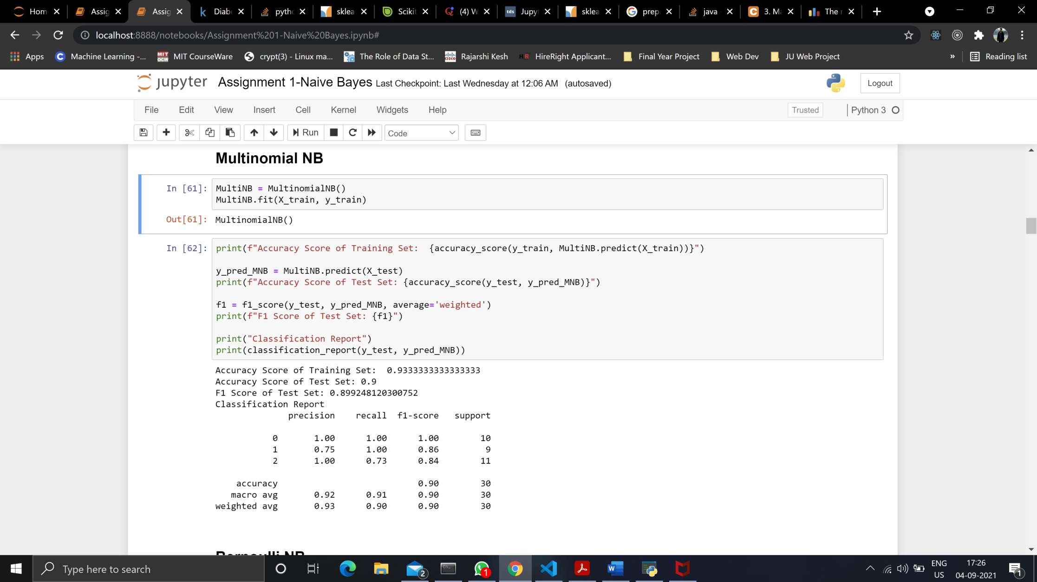

**Bernoulli Naïve Bayes**

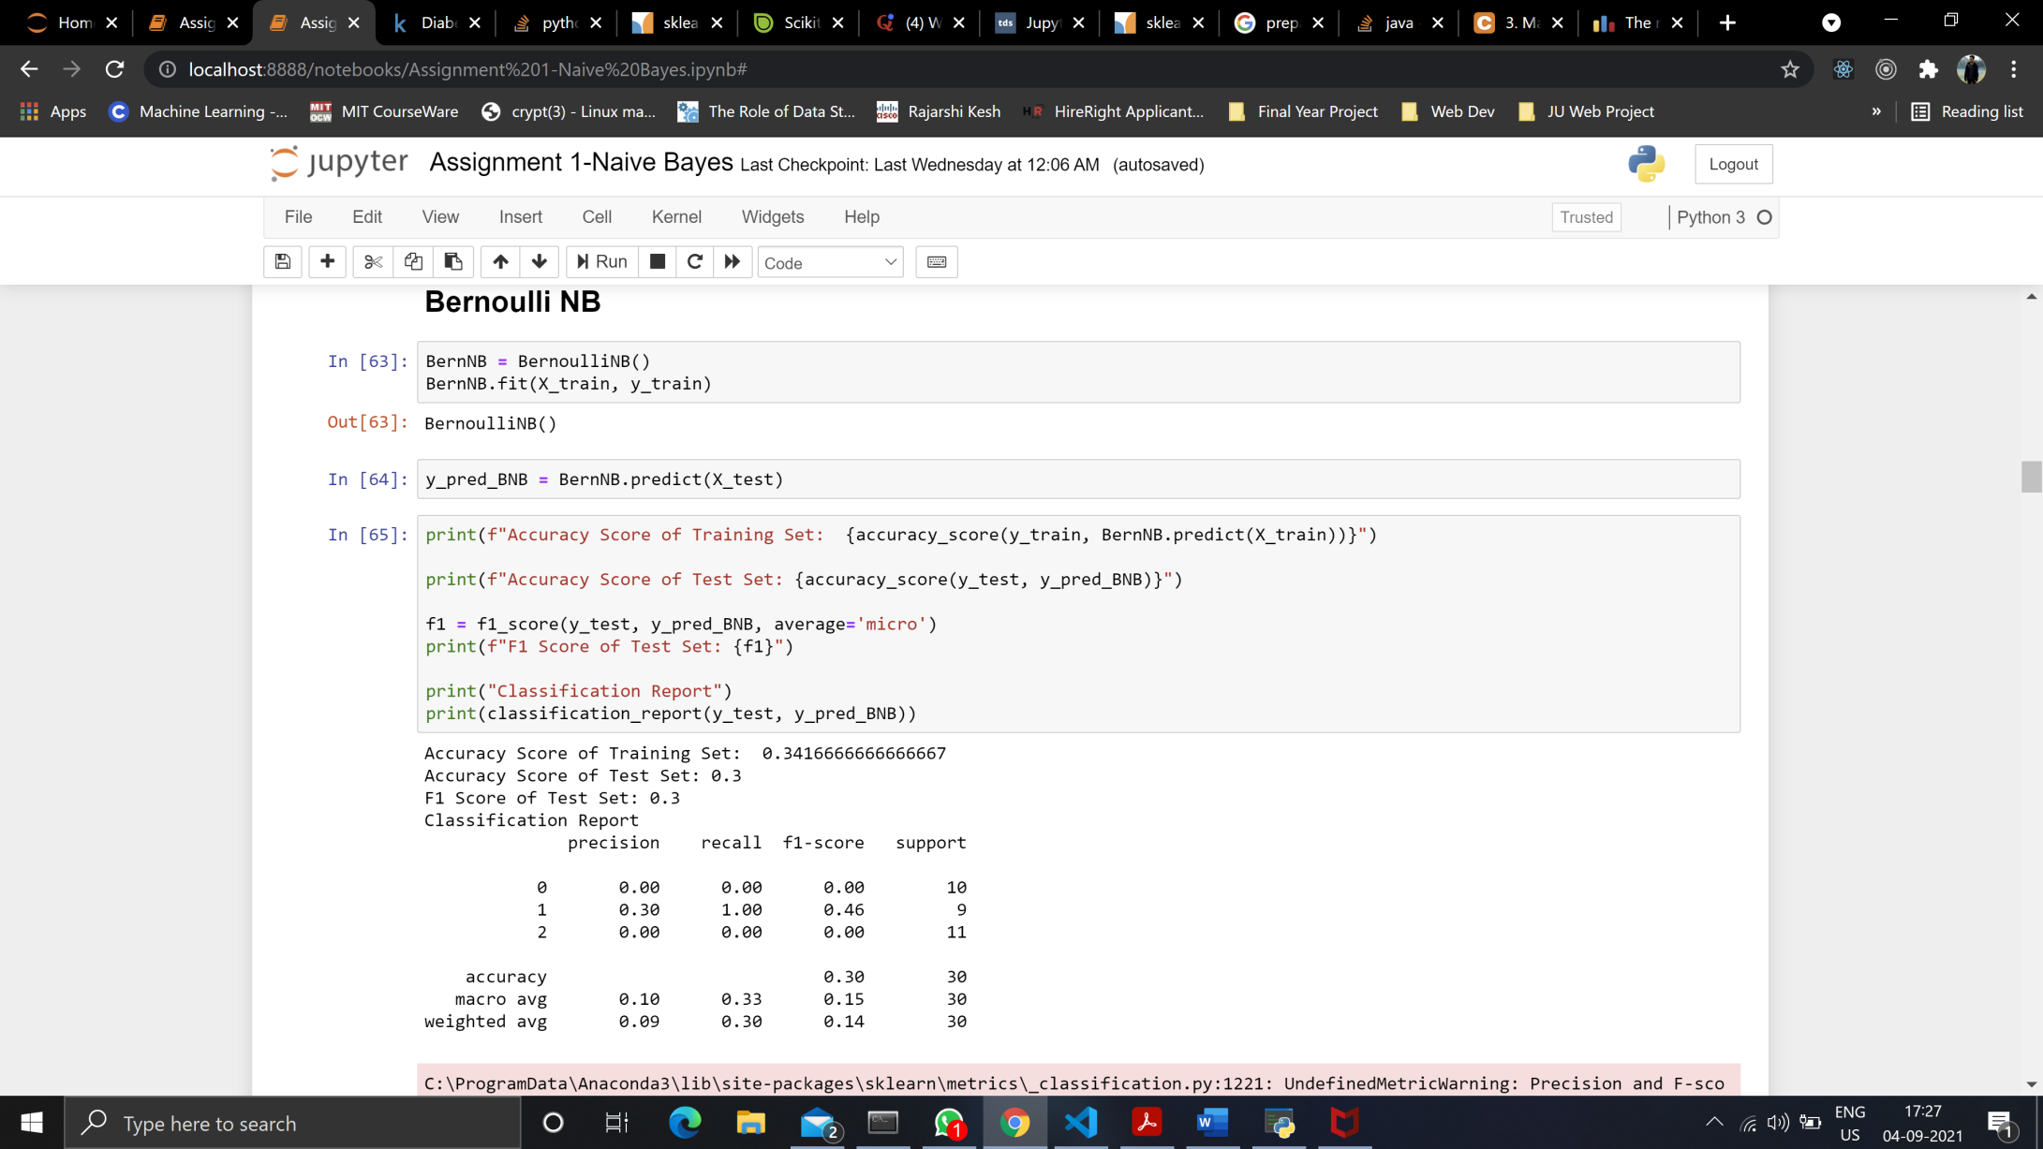

***Gaussian Naïve Bayes***

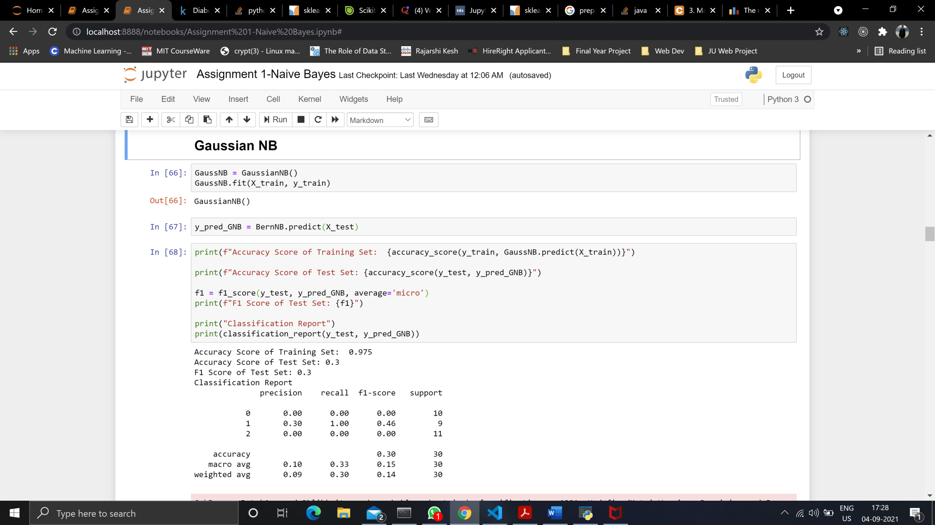

**As we can see by running the above algorithms on the Iris Dataset, Multinomial Naïve Bayes gives the best result.**

**DIABETES DATASET**

***Prepare Dataset for training***

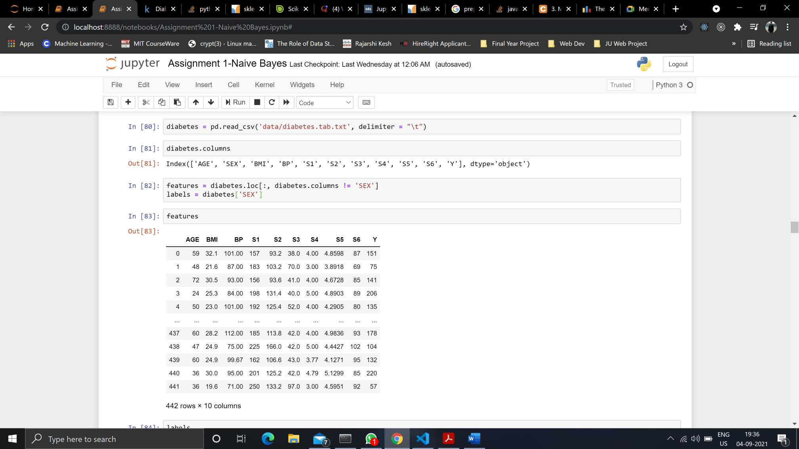

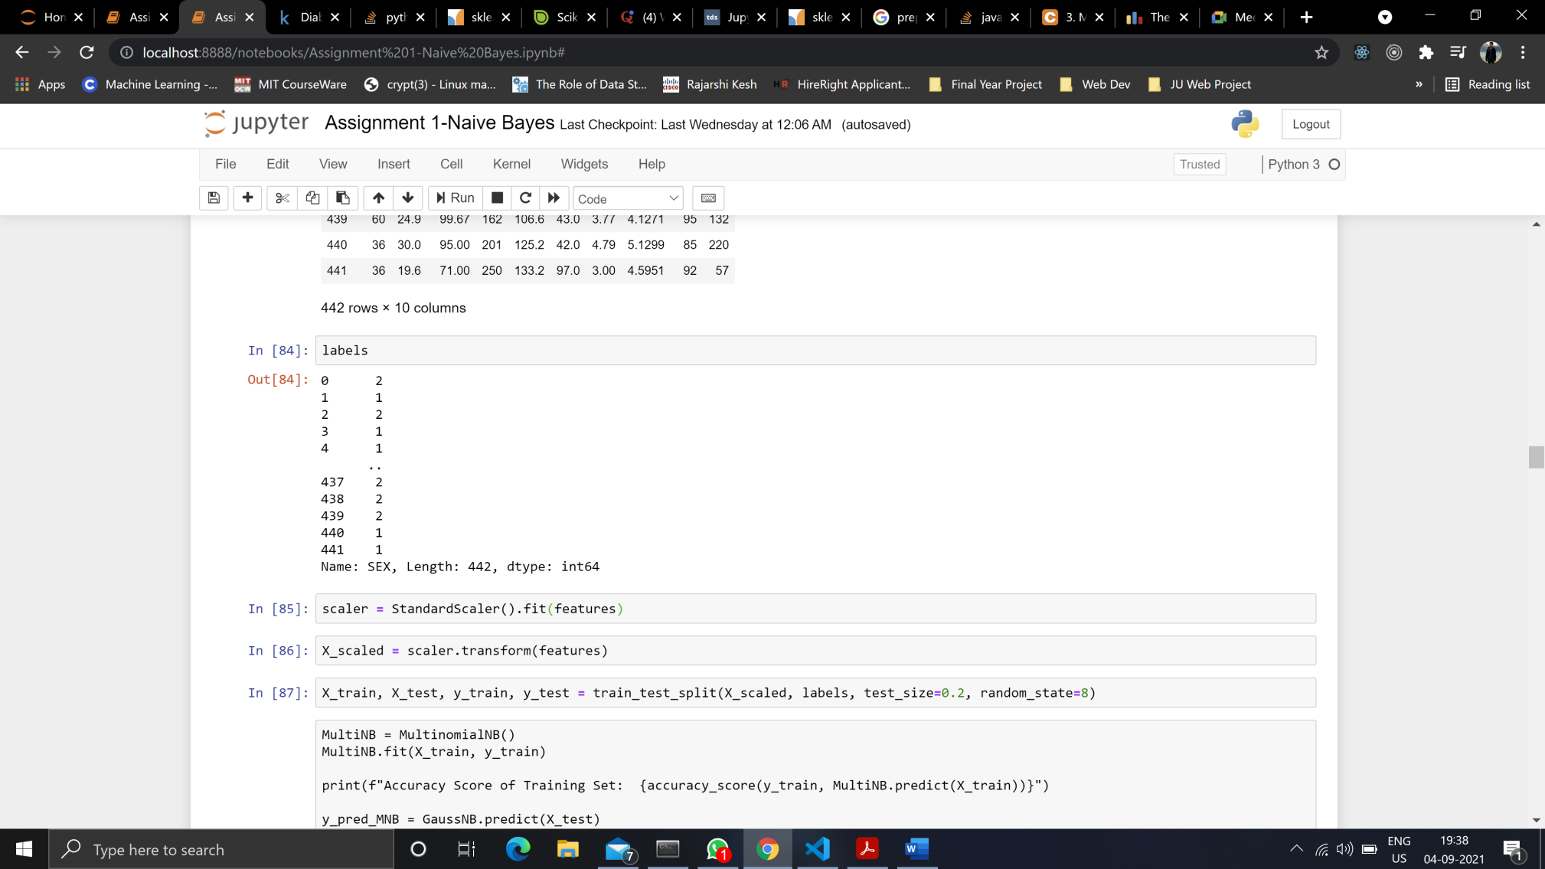

**Multinomial Naïve Bayes** algorithm is not applicable to negative feature values

***Bernoulli Naïve Bayes***

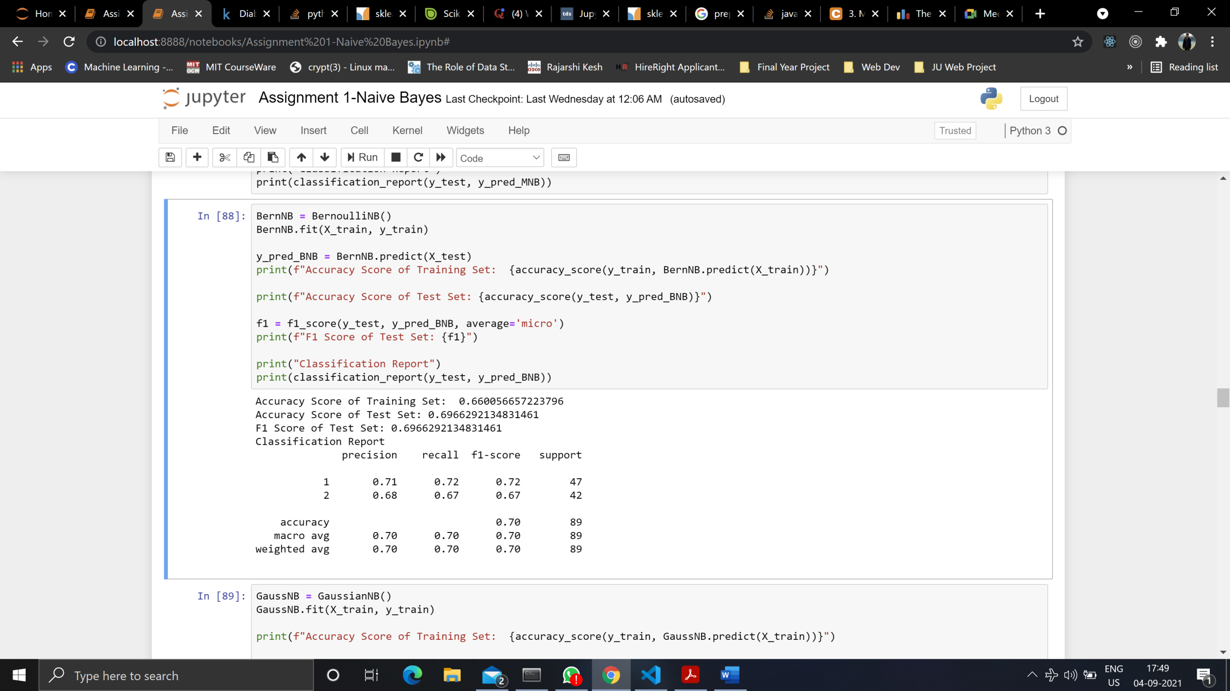

***Gaussian Naïve Bayes***

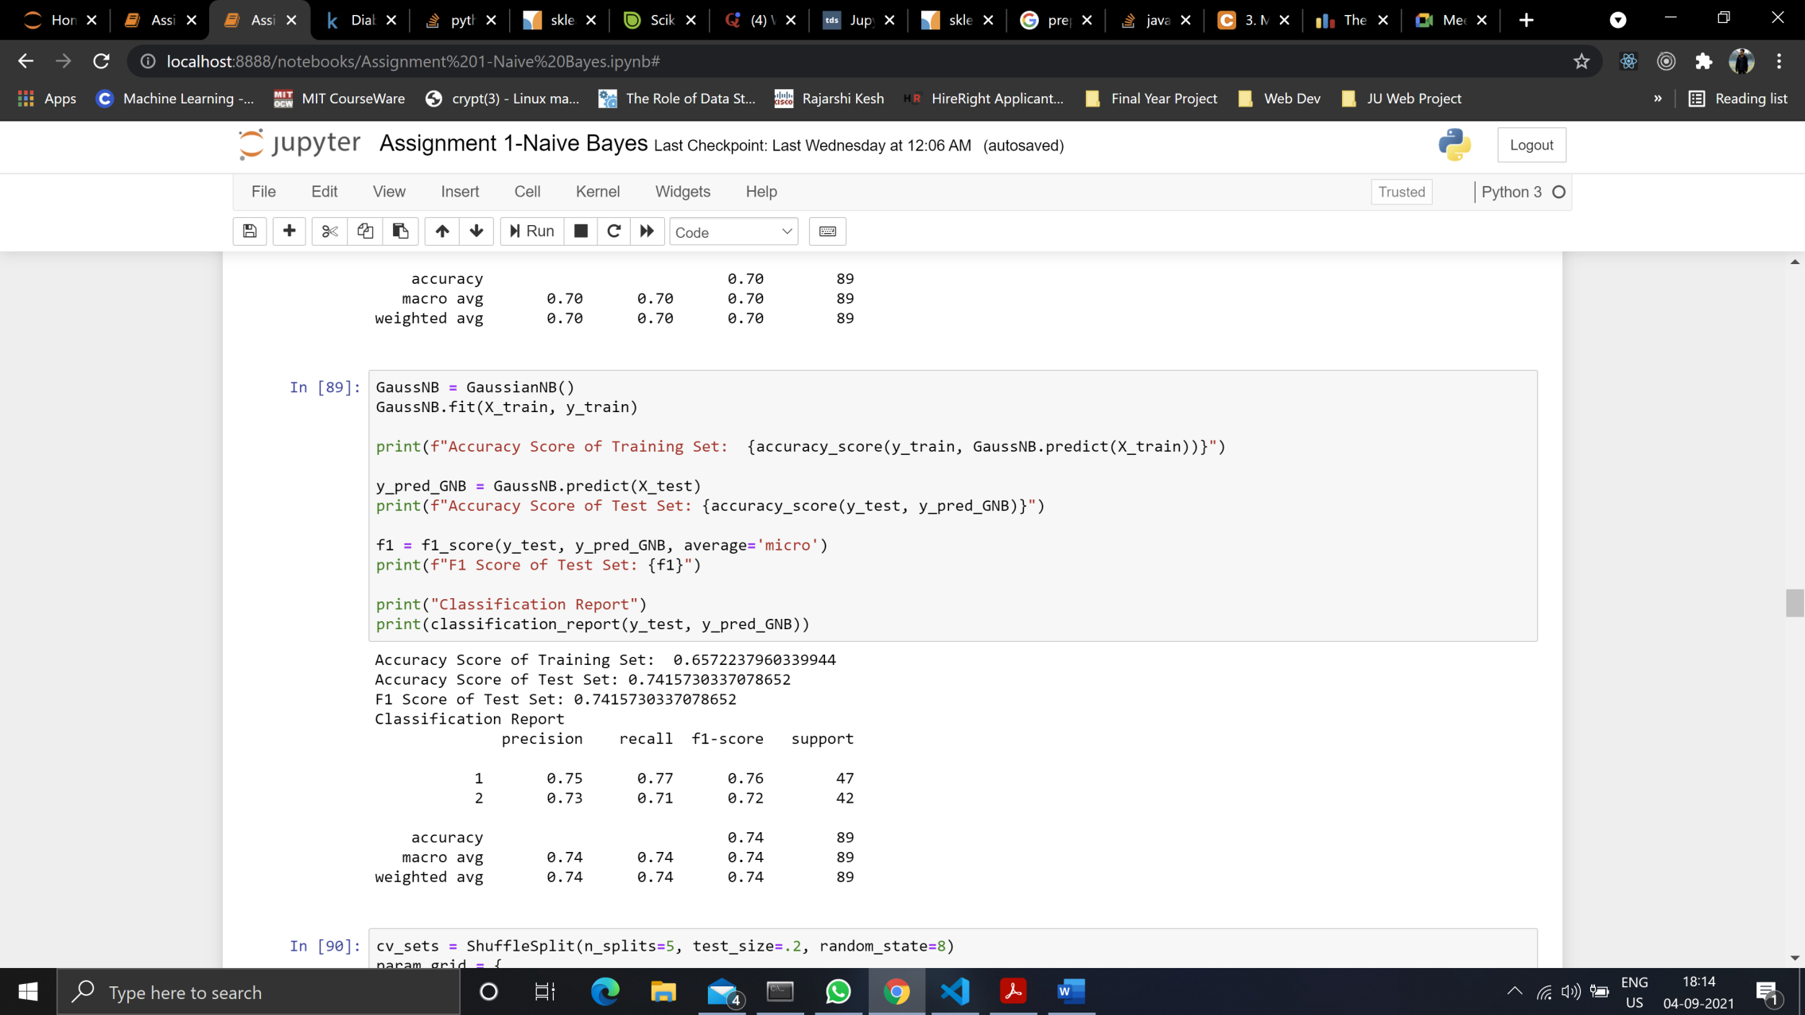

**As we can see by running the algorithms, Gaussian Naïve Bayes gives the best result.**

**BREAST CANCER DATASET**

***Prepare Dataset***

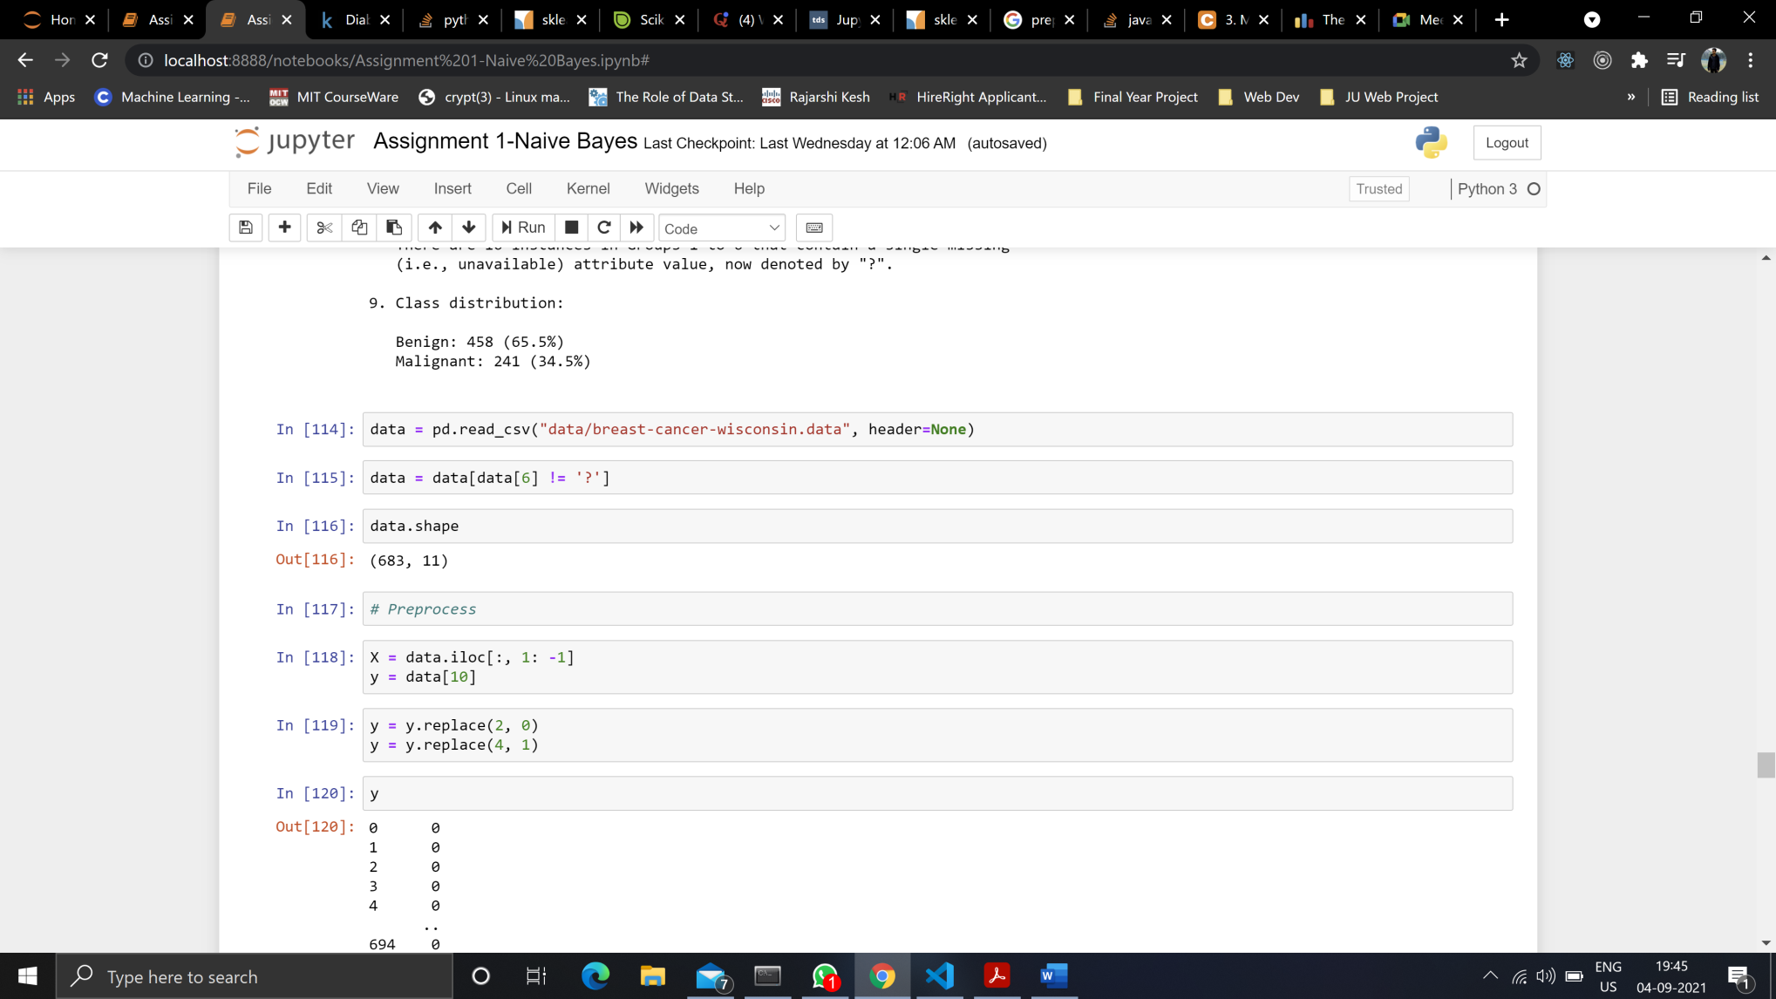

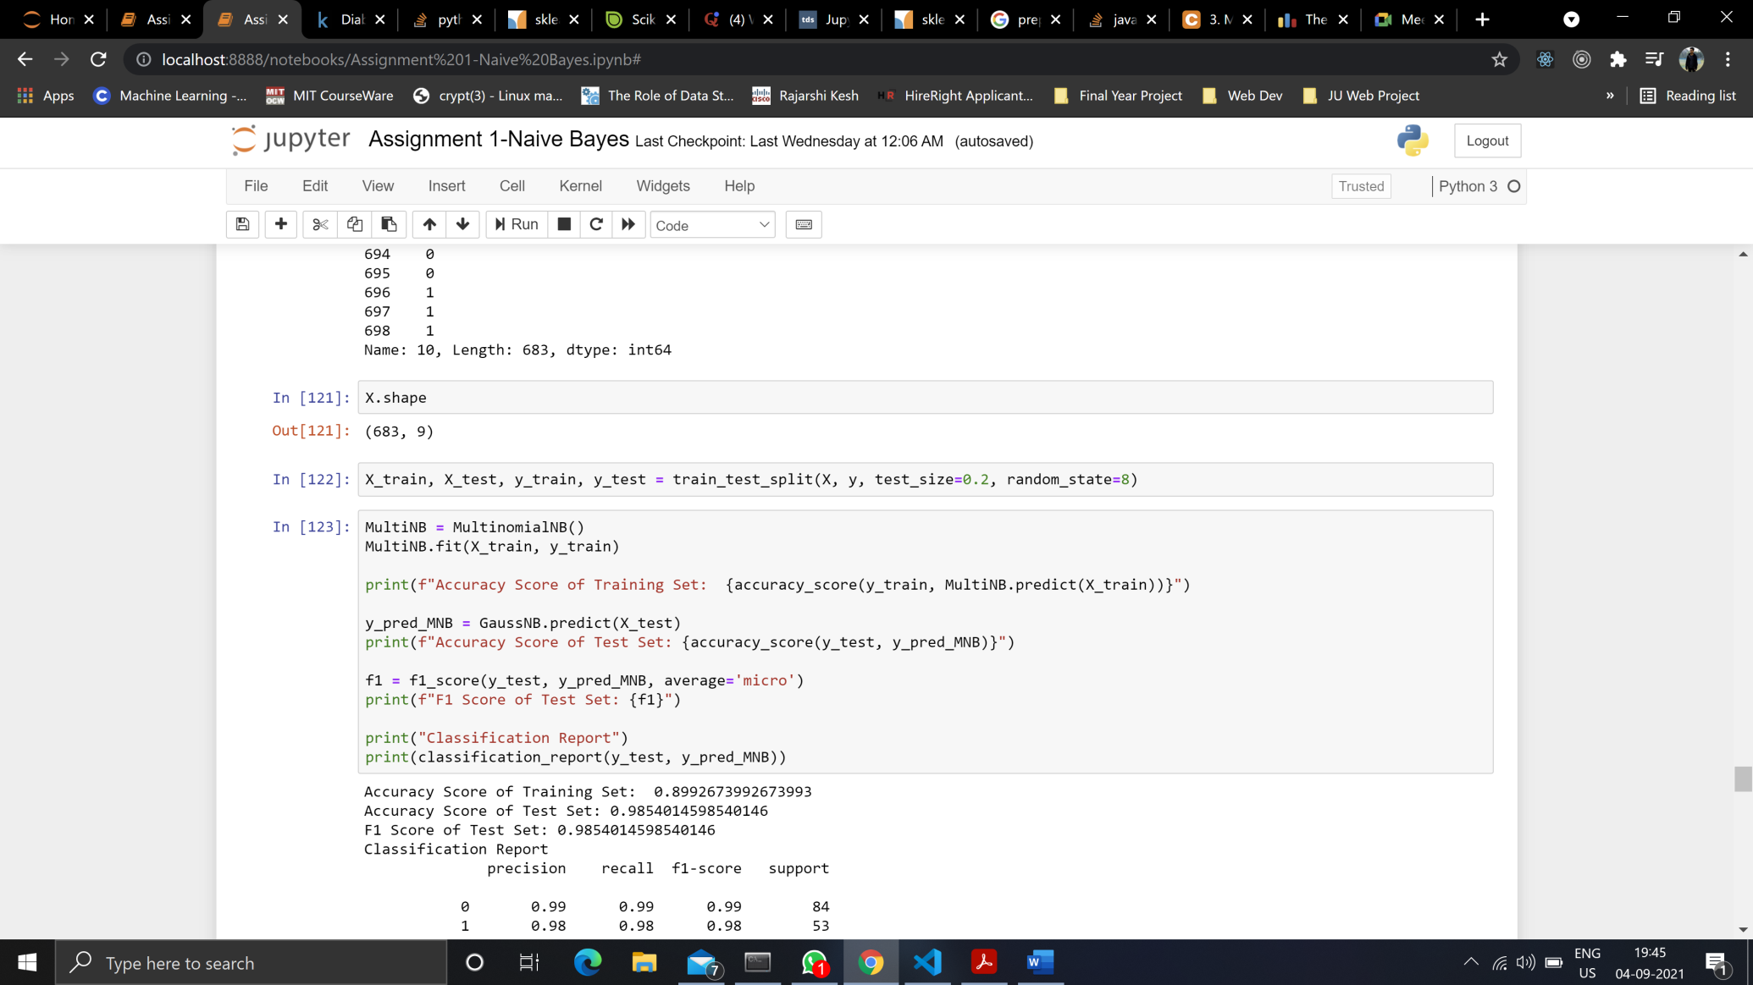

***Multinomial Naïve Bayes***

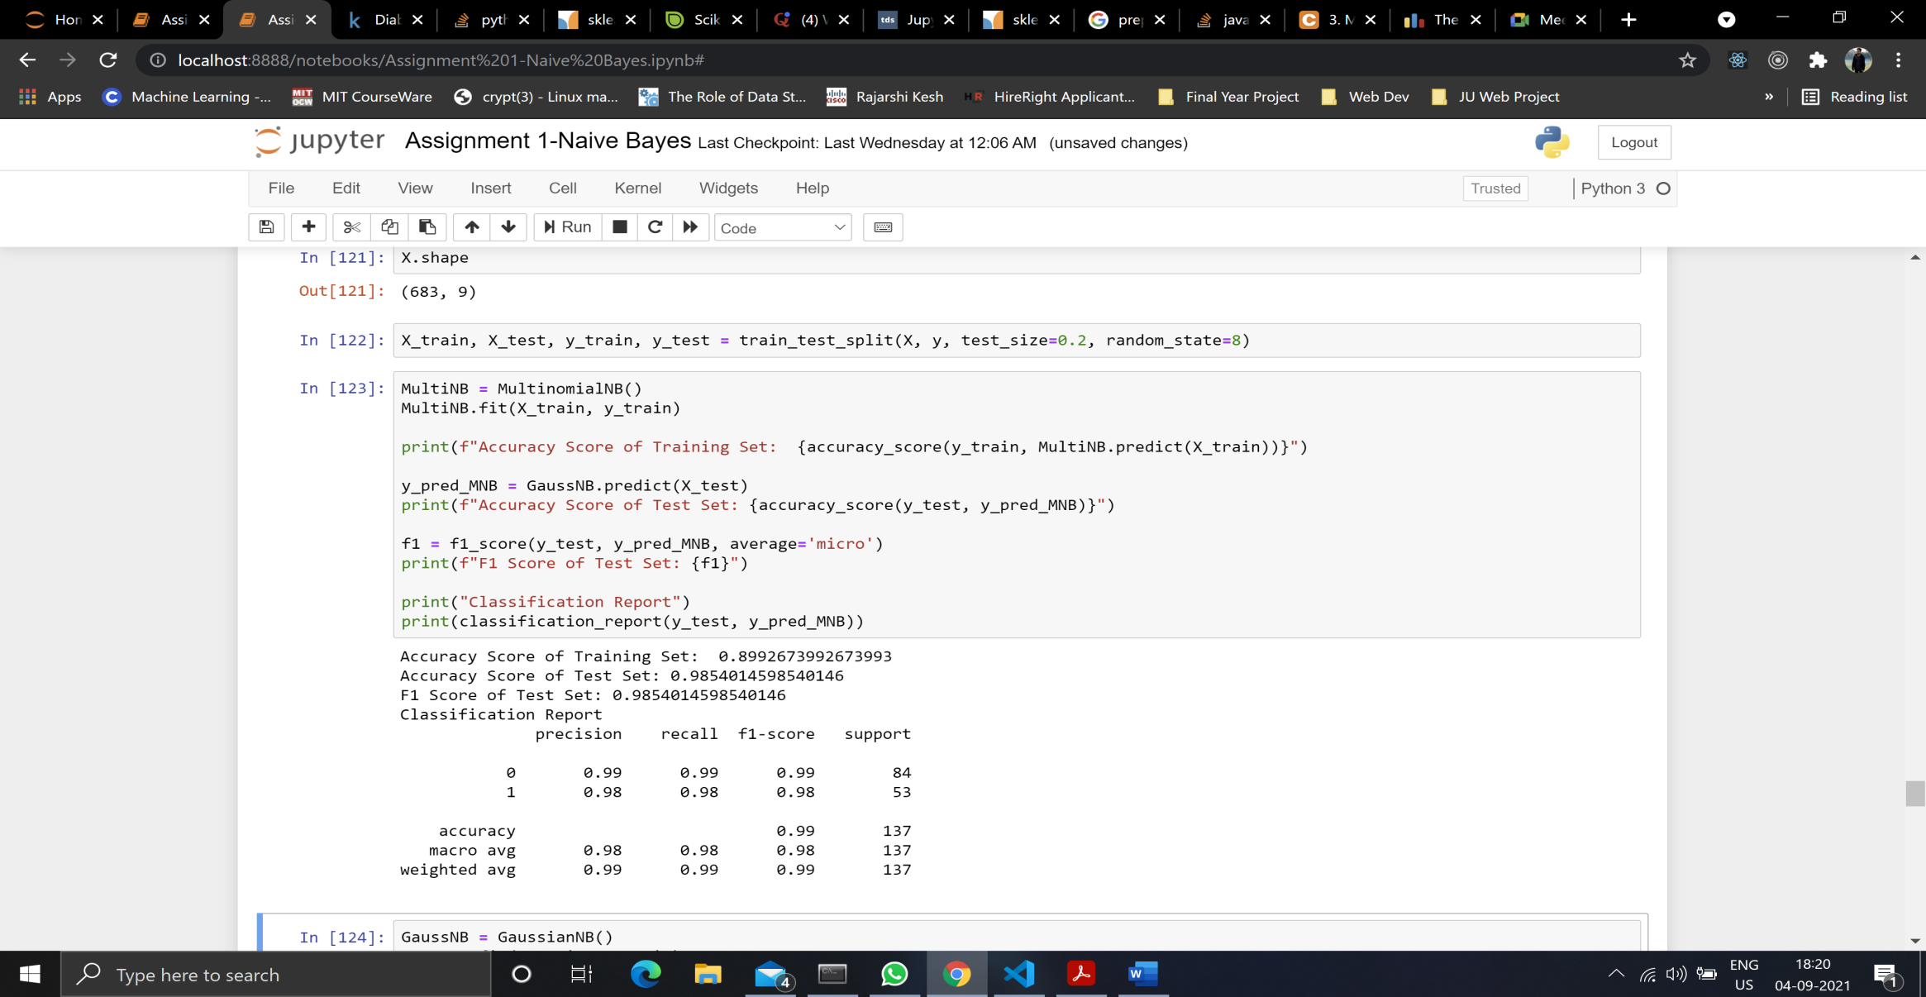

***Bernoulli Naïve Bayes***

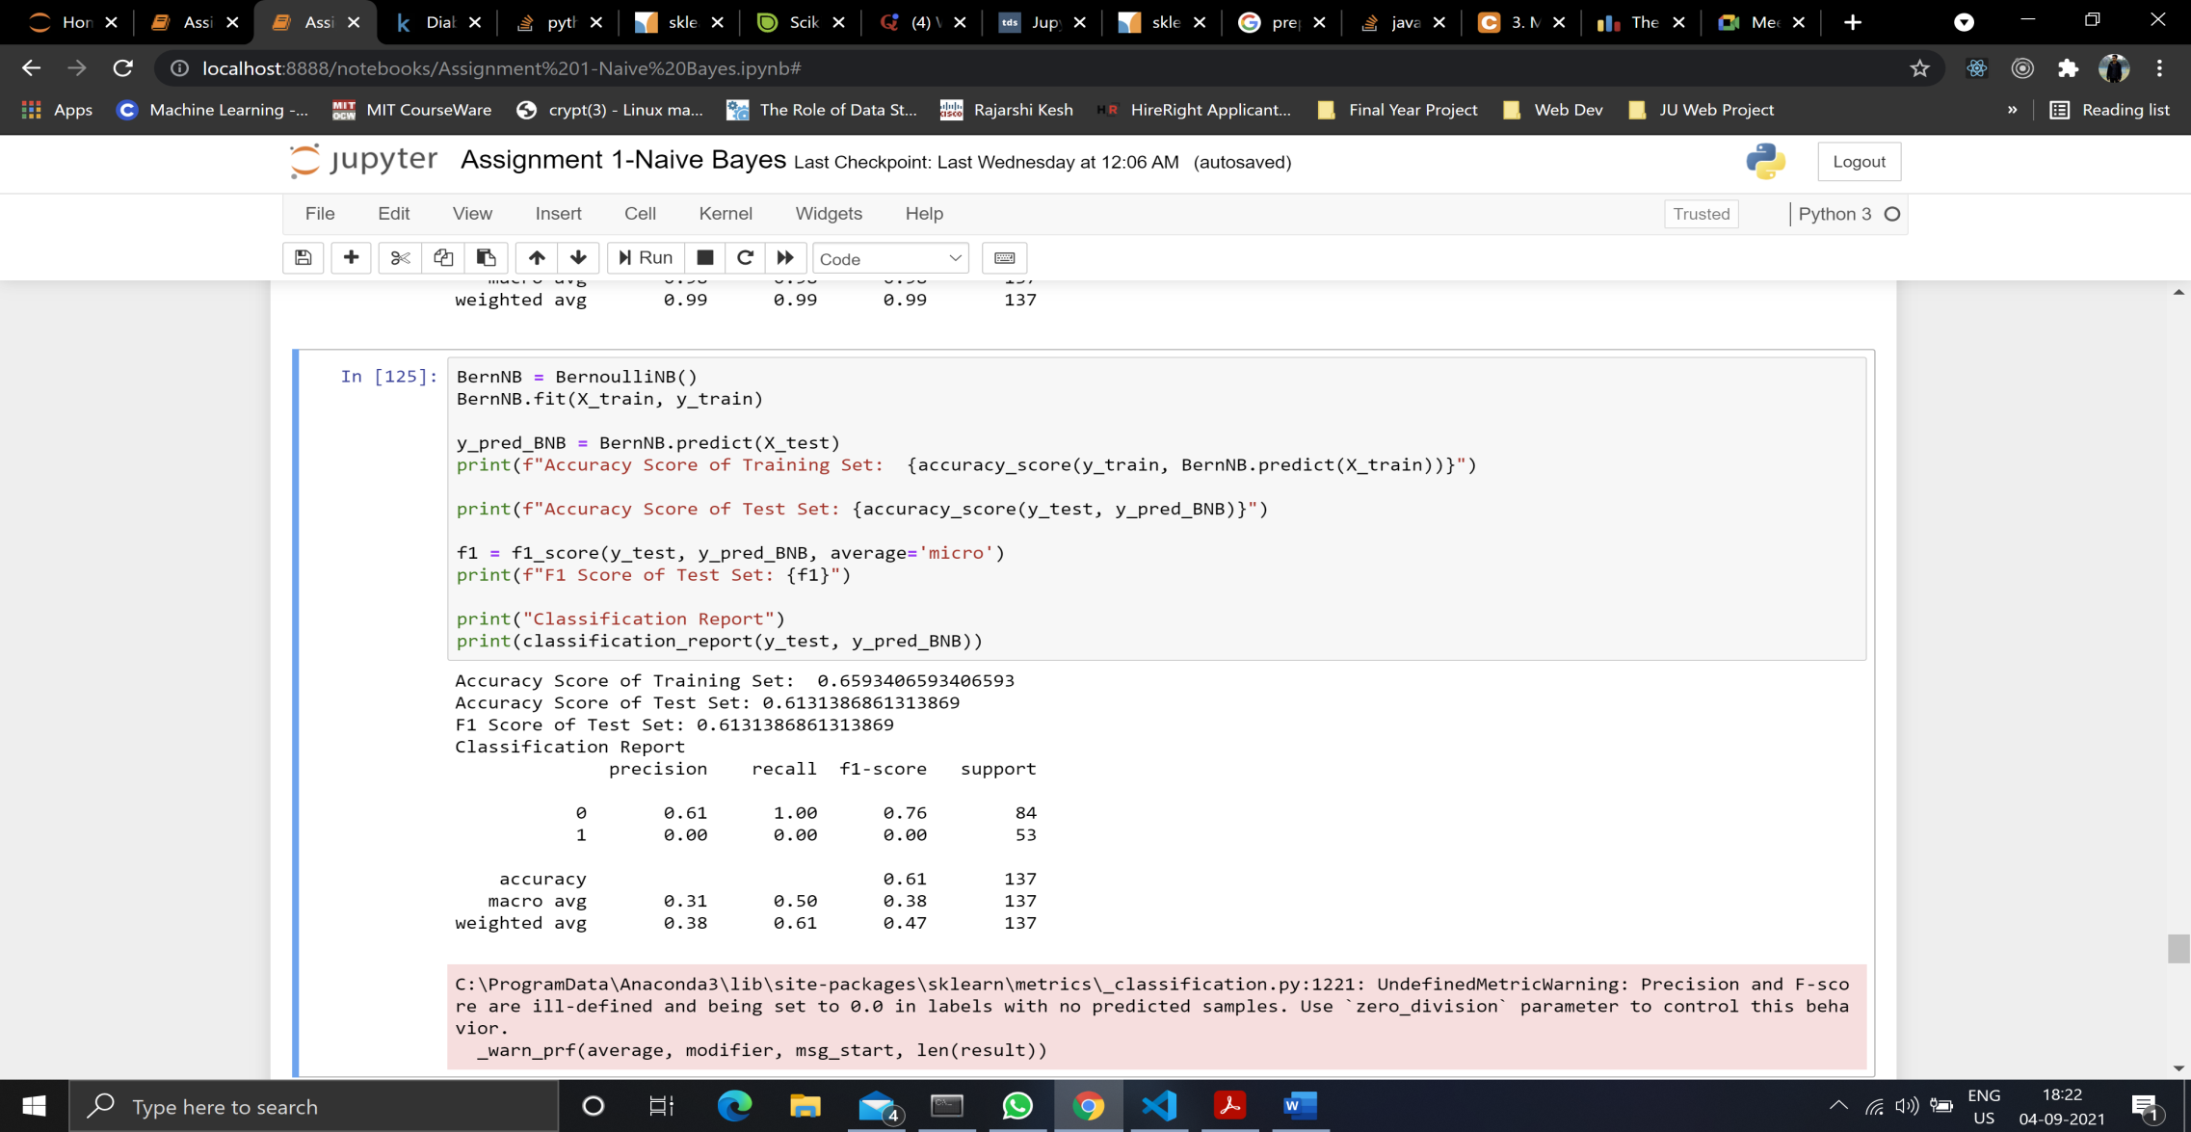

***Gaussian Naïve Bayes***

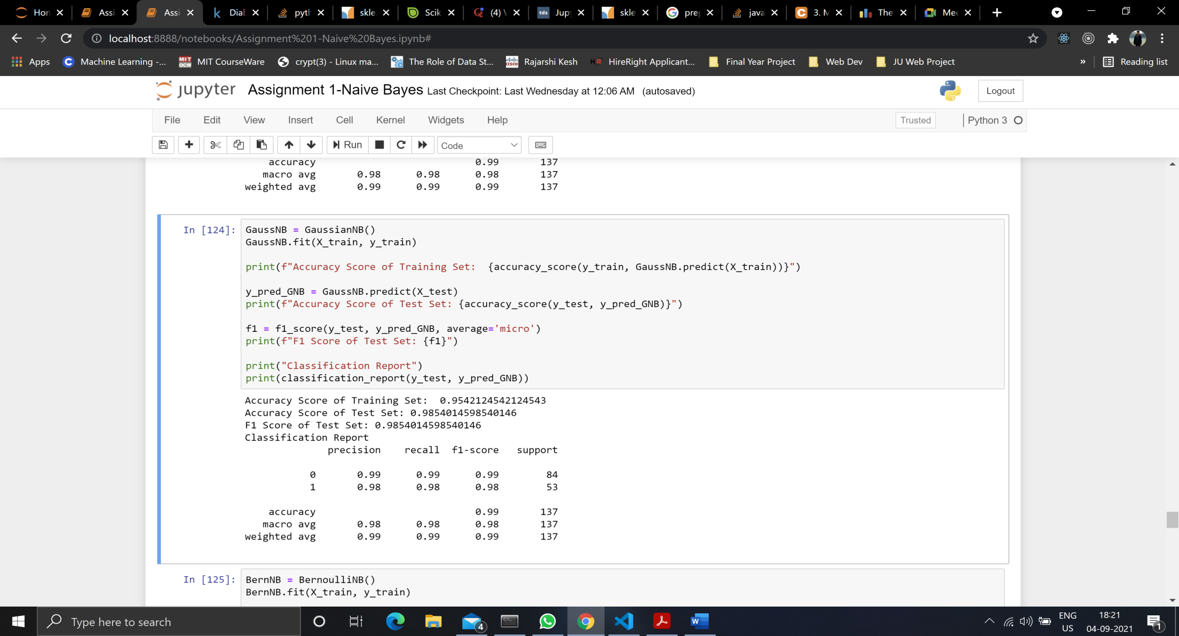

**As we can see by running the algorithms, Gaussian Naïve Bayes gives the best result.**

***Question 2*:** Decision Tree Algorithm on all datasets

*Datasets can be prepared in the same way as mentioned above.*

**IRIS DATASET**

***Without Parameter Tuning***

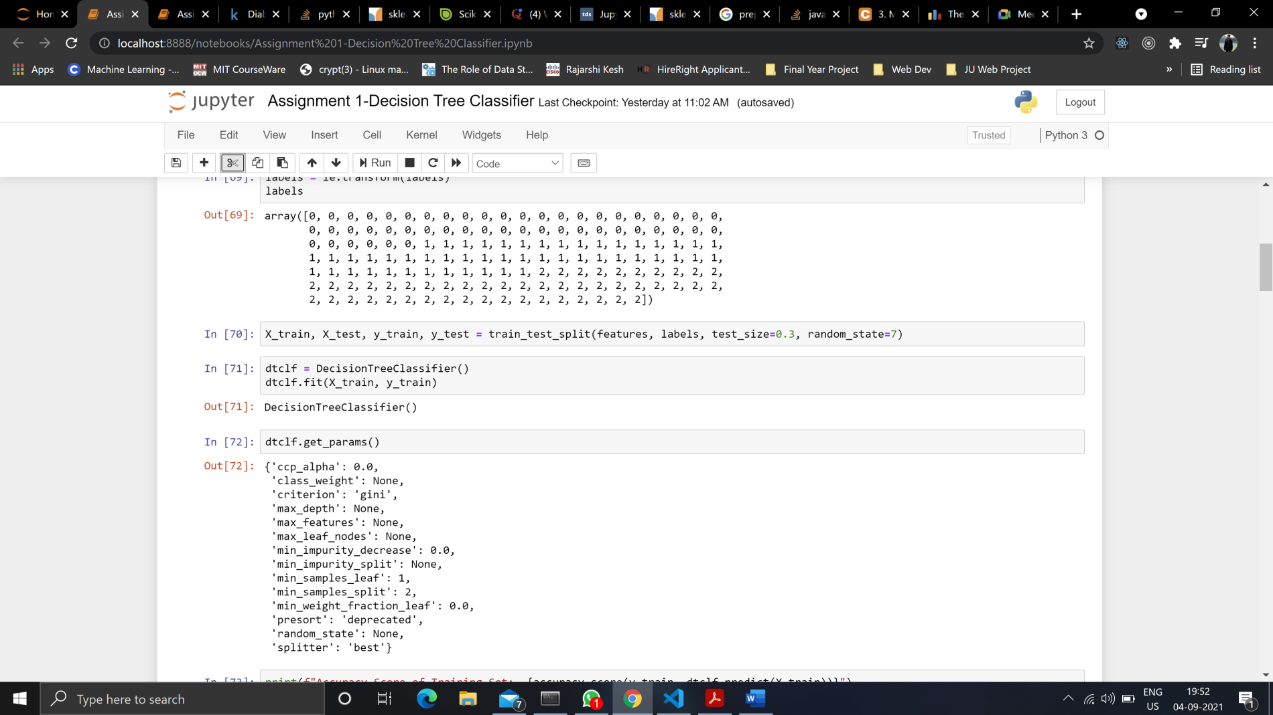

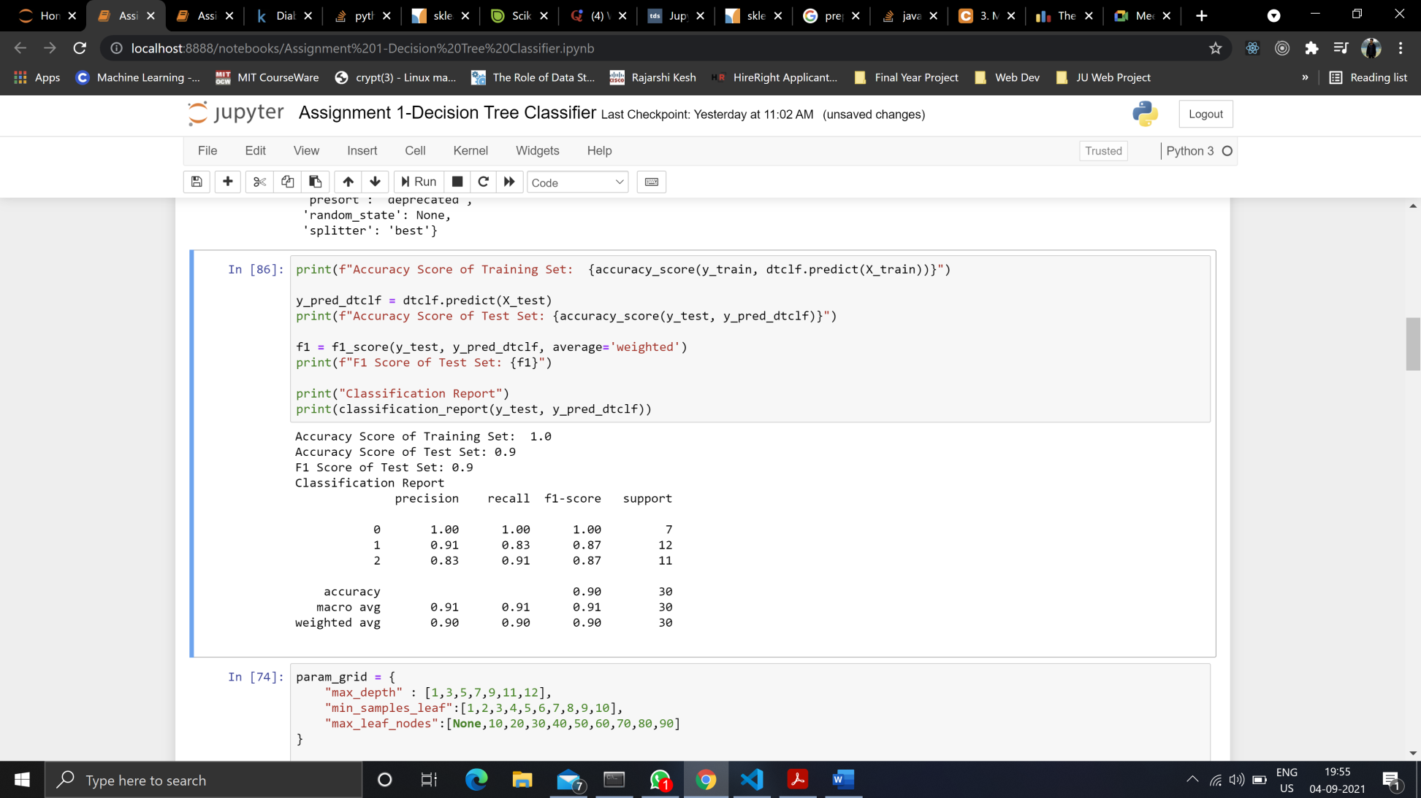

***With Parameter Tuning***

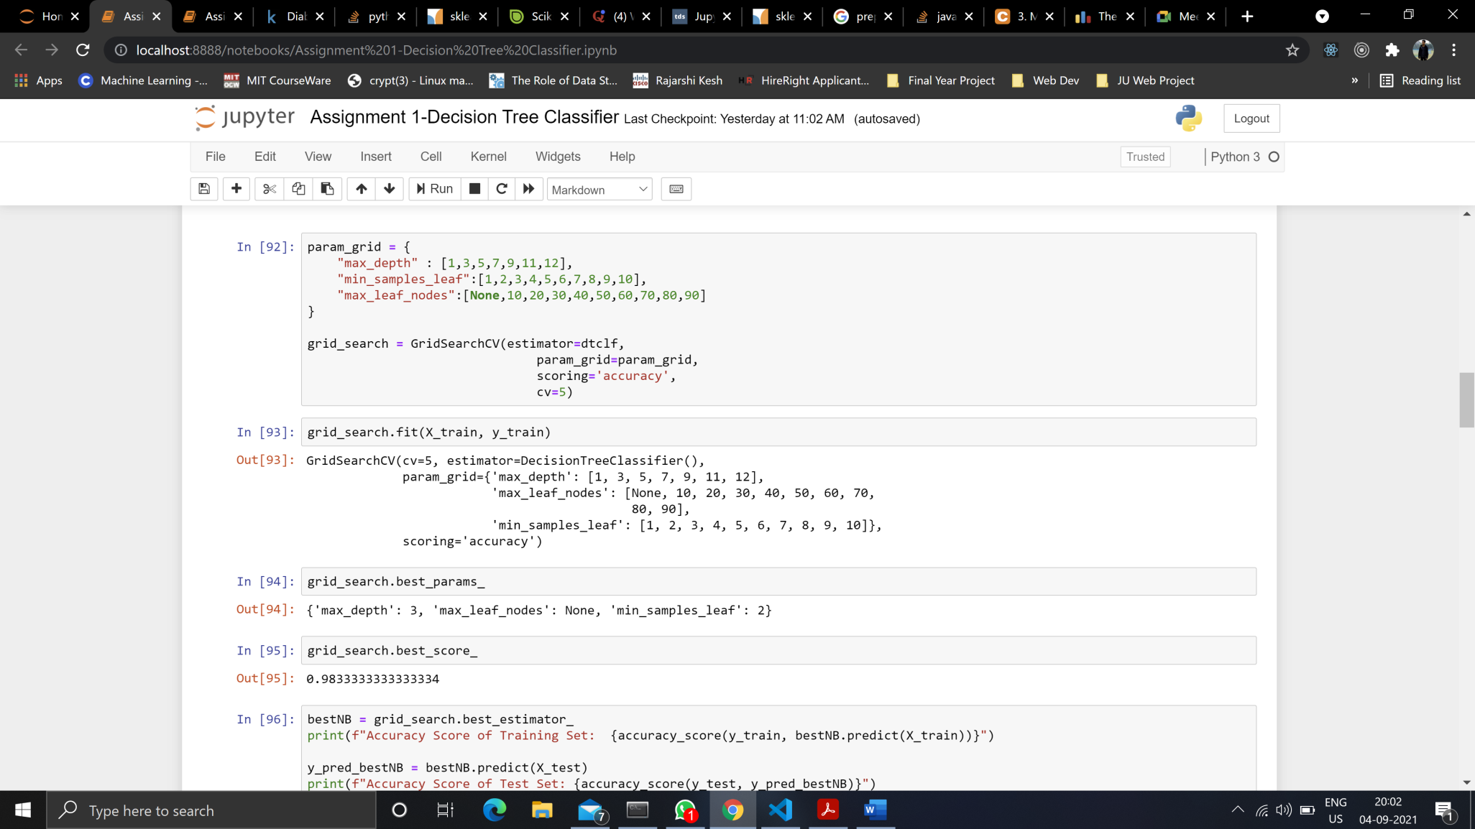

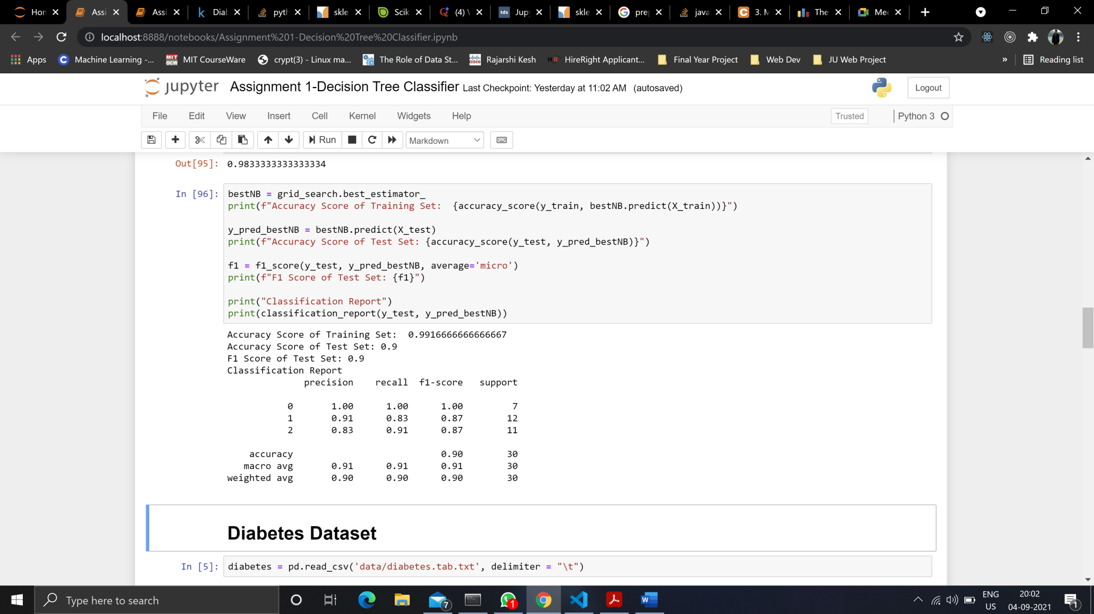

**Observation**: There is a very small improvement in the algorithm upon parameter tuning.

**DIABETES DATASET**

***Without Parameter Tuning***

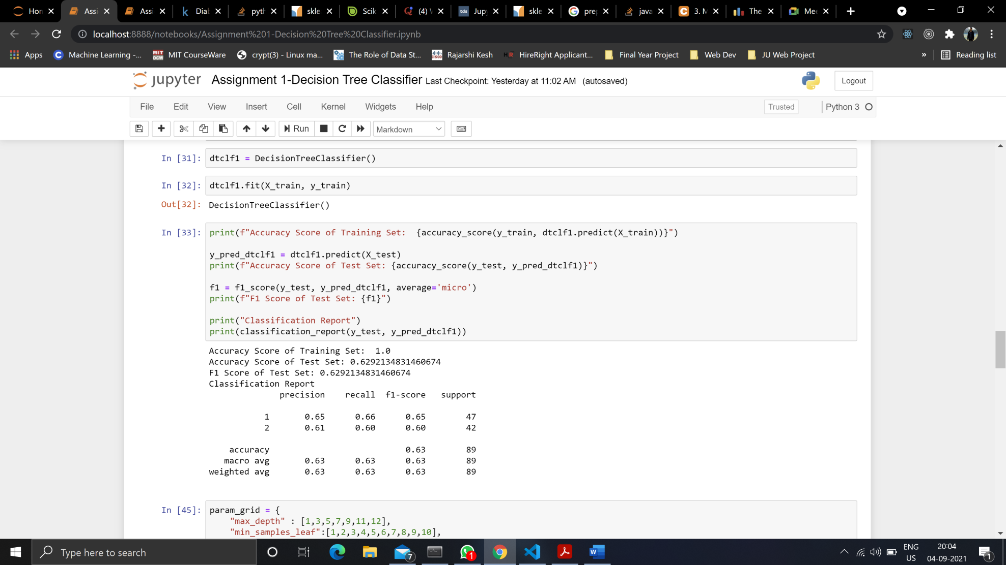

***With Parameter Tuning***

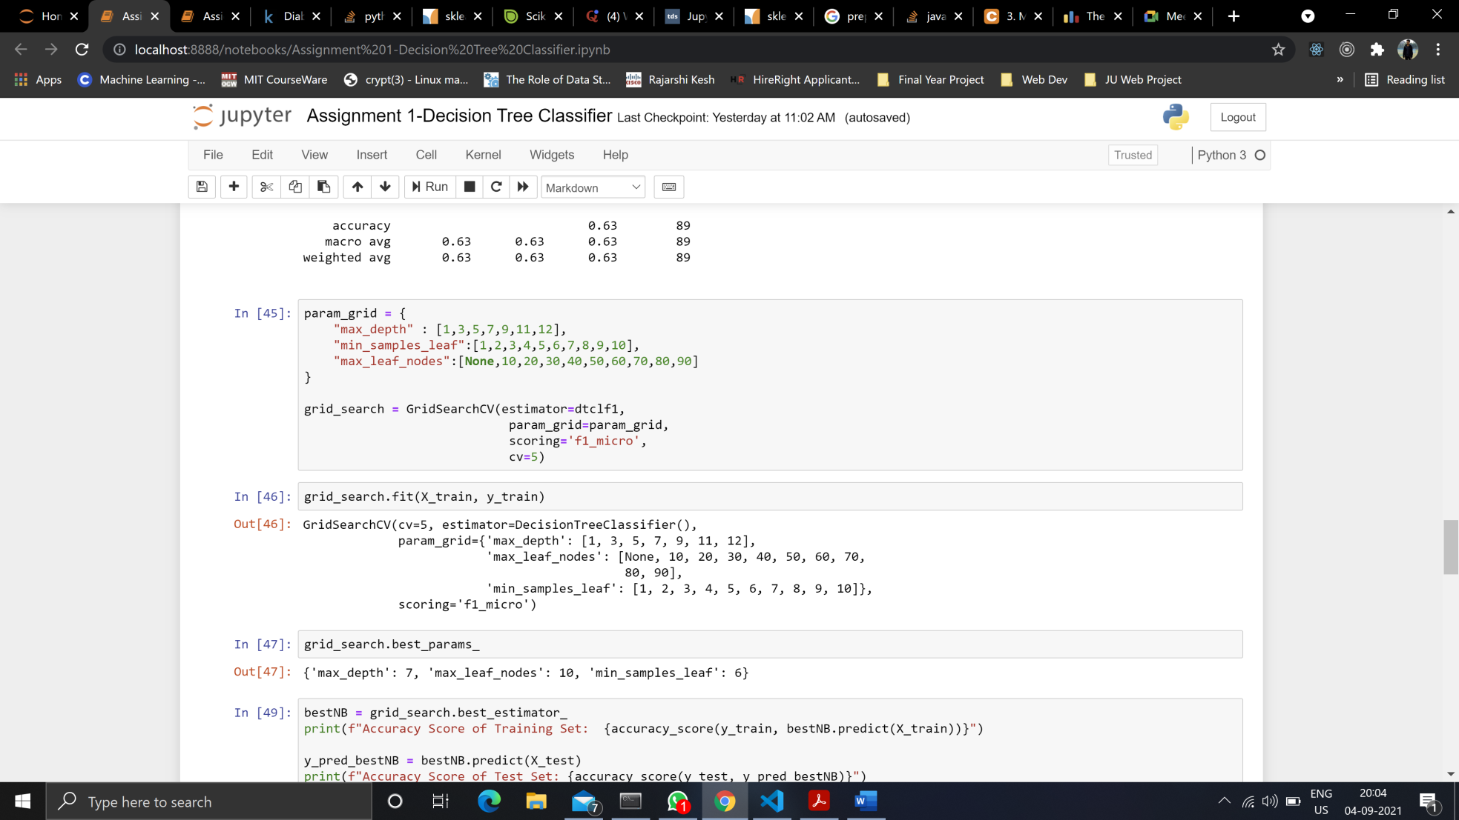

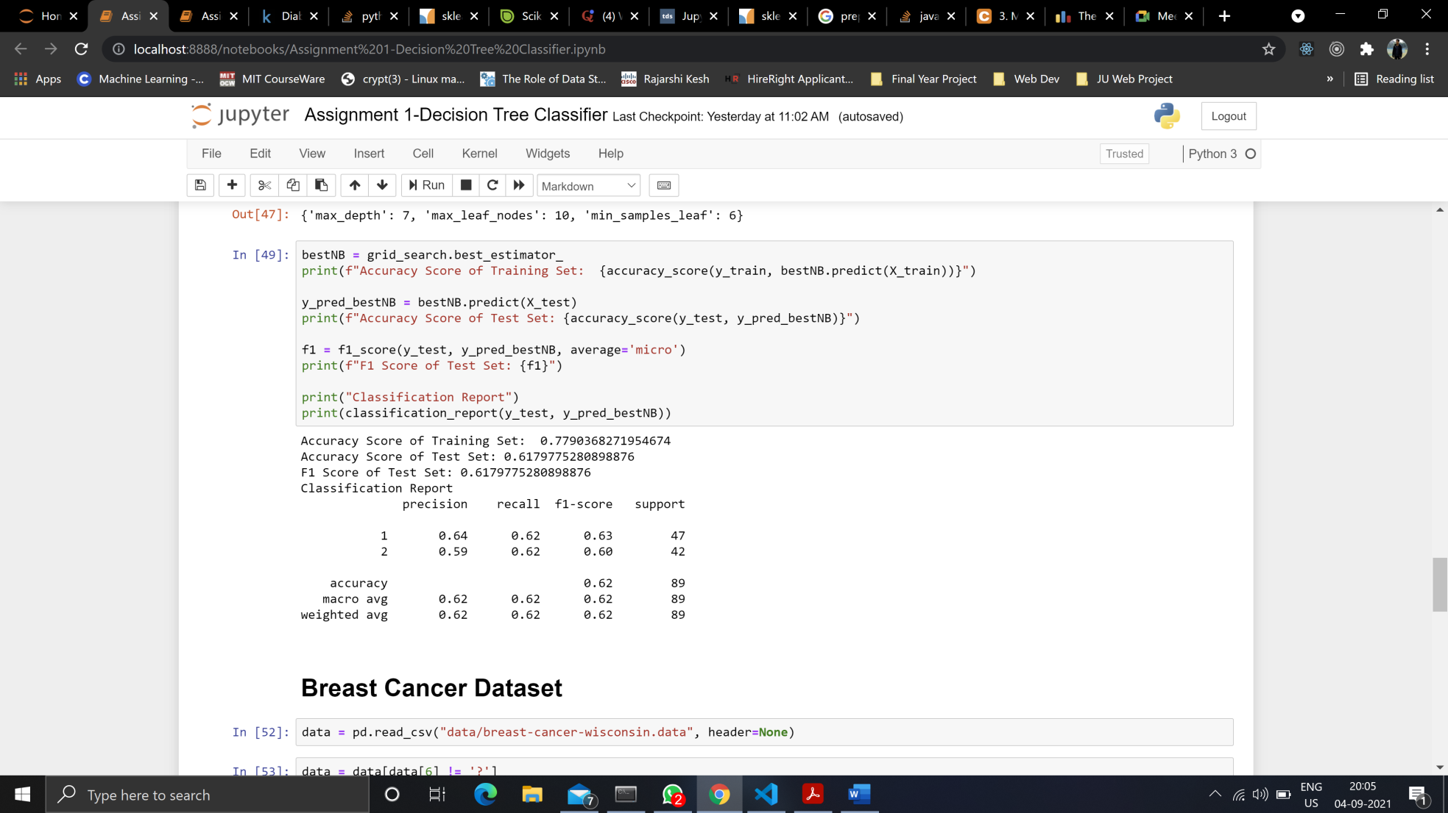

**Observation**: As we can see, there is no real improvement in model upon parameter tuning. However, the tuned algorithm is not overfitting the data unlike the untuned algorithm.

**BREAST CANCER DATASET**

***Without parameter tuning***

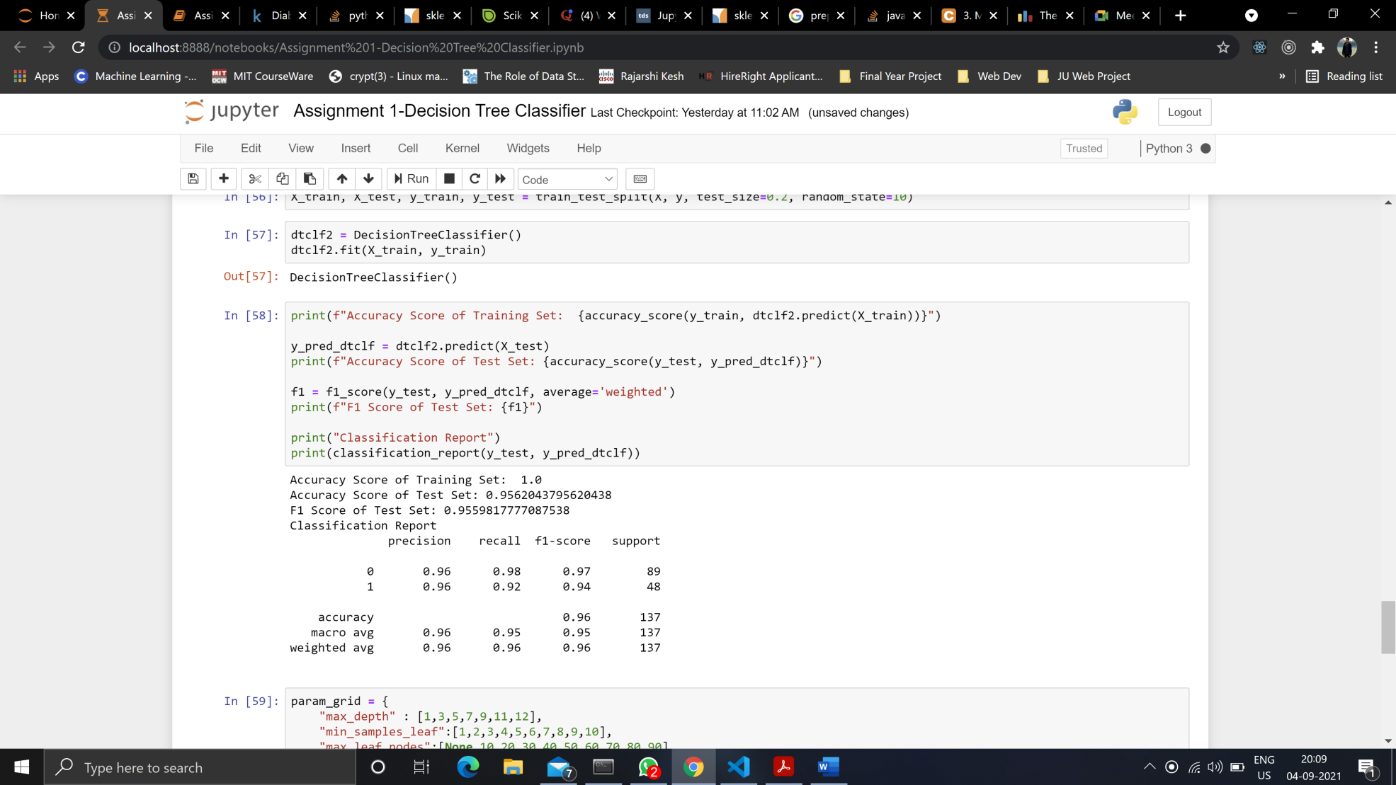

***With Parameter Tuning***

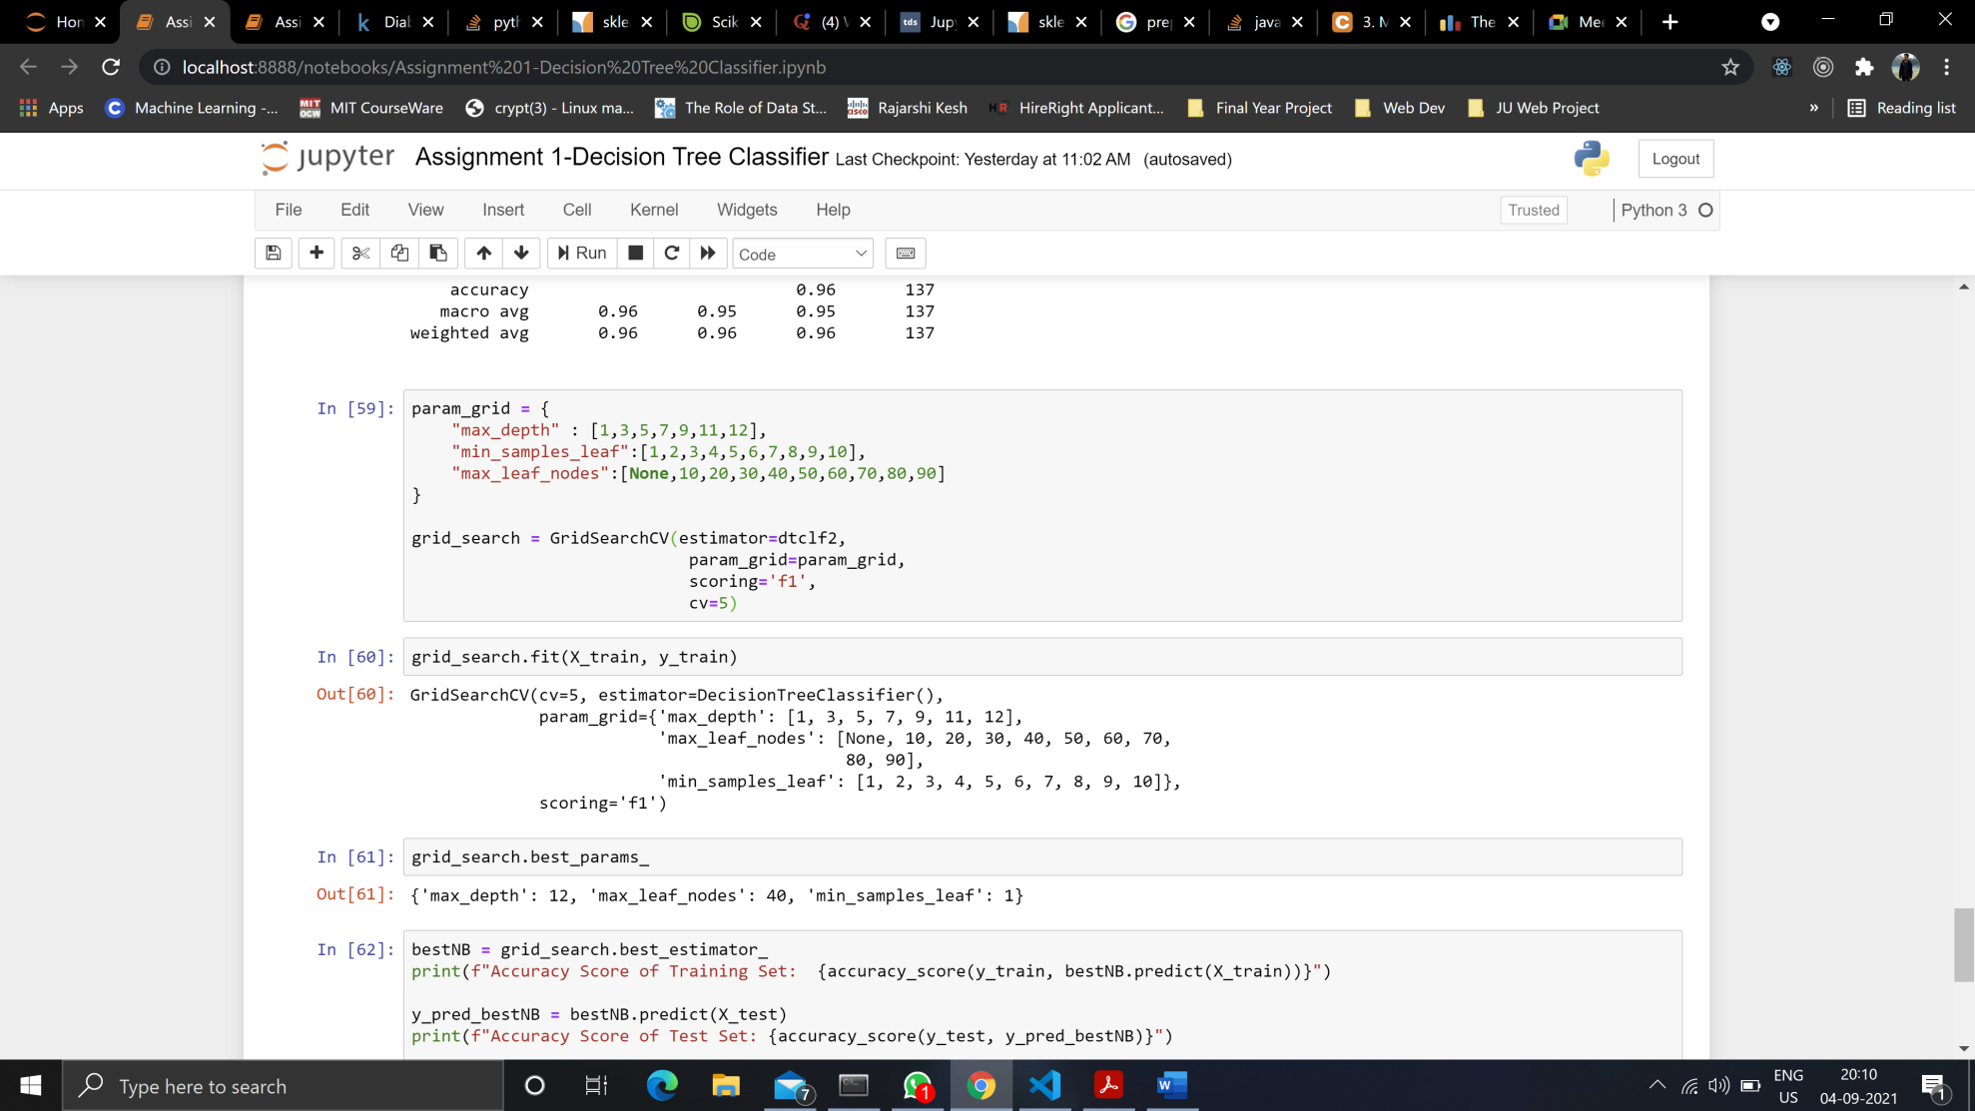

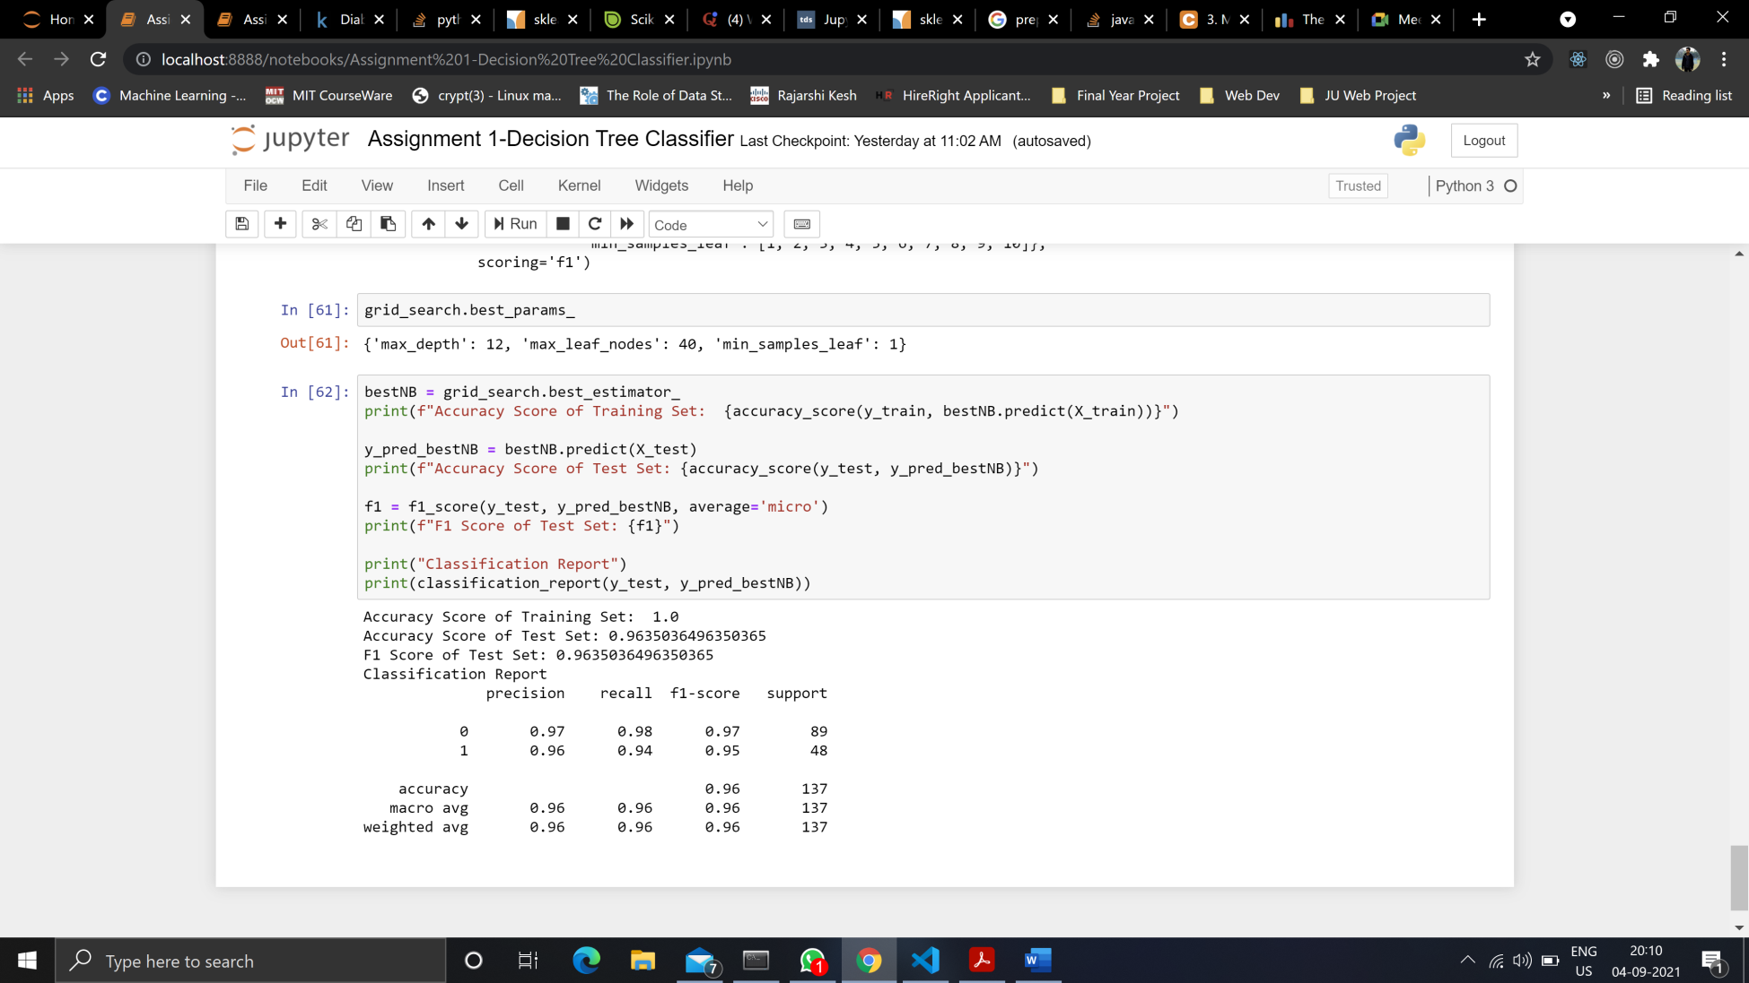

**Observation**: There is small improvement in the model upon tuning.